**CONTENTS PAGE NO**

1. **INTRODUCTION** 
   1. Overview
   2. Purpose
2. **PROBLEM DEFINITION & DESIGN THINKING**
   1. Empathy Map
   2. Ideation & Brainstorming Map
3. **RESULT**
4. **ADVANTAGES & DISADVANTAGES**
5. **APPLICATIONS**
6. **CONCLUSION**
7. **FUTURE SCOPE**
8. **APPENDIX**
   1. Source Code

**INTRODUCTION**

The system for collecting and sending letters and packages. A way of sending electronic messages or data from one computer to another. A responsive email is an email that looks good on any device, whether it’s a desktop, tablet, or mobile phone. The email automatically adapts to all screen resolutions, allowing subscribers to read emails on the go with convenience and meeting a modern demand in mobile presence. Email (electronic mail) is the exchange of computer-stored messages from one user to one or more recipients via the internet.

* 1. **Overview:**
* **User Convenience**: An email input makes it easier for users to enter their email addresses as it provides a clear indication of the data expected in the field.
* **Personalized Communication**: Collecting email addresses from users through a form allows for personalized communication, such as sending confirmation emails or newsletters.
* **Lead Generation**: By collecting email addresses through a form, businesses can build their email list and use it for lead generation.
* **User Authentication**: Email addresses can be used as a means of authentication for accessing restricted content or services.
* **Feedback Collection**: An email input in a feedback form allows the business to communicate with the user for follow-up or clarification on their feedback.

**1.2. Purpose:**

* The Adaptive Form Email input Core Component is used to collect email addresses from users. The email input field allows the browser to validate that the entered data is a valid

email address format.

* Outstanding commitments, requests, and follow-ups to and from other collaborators in email that might have fallen through the cracks.
* Documents related to today’s meetings that you might want to review beforehand.
* Suggested focus time you can schedule to help get independent work done.

**PROBLEM DEFINITION & DESIGN THINKING**

2.1 Empathy Map

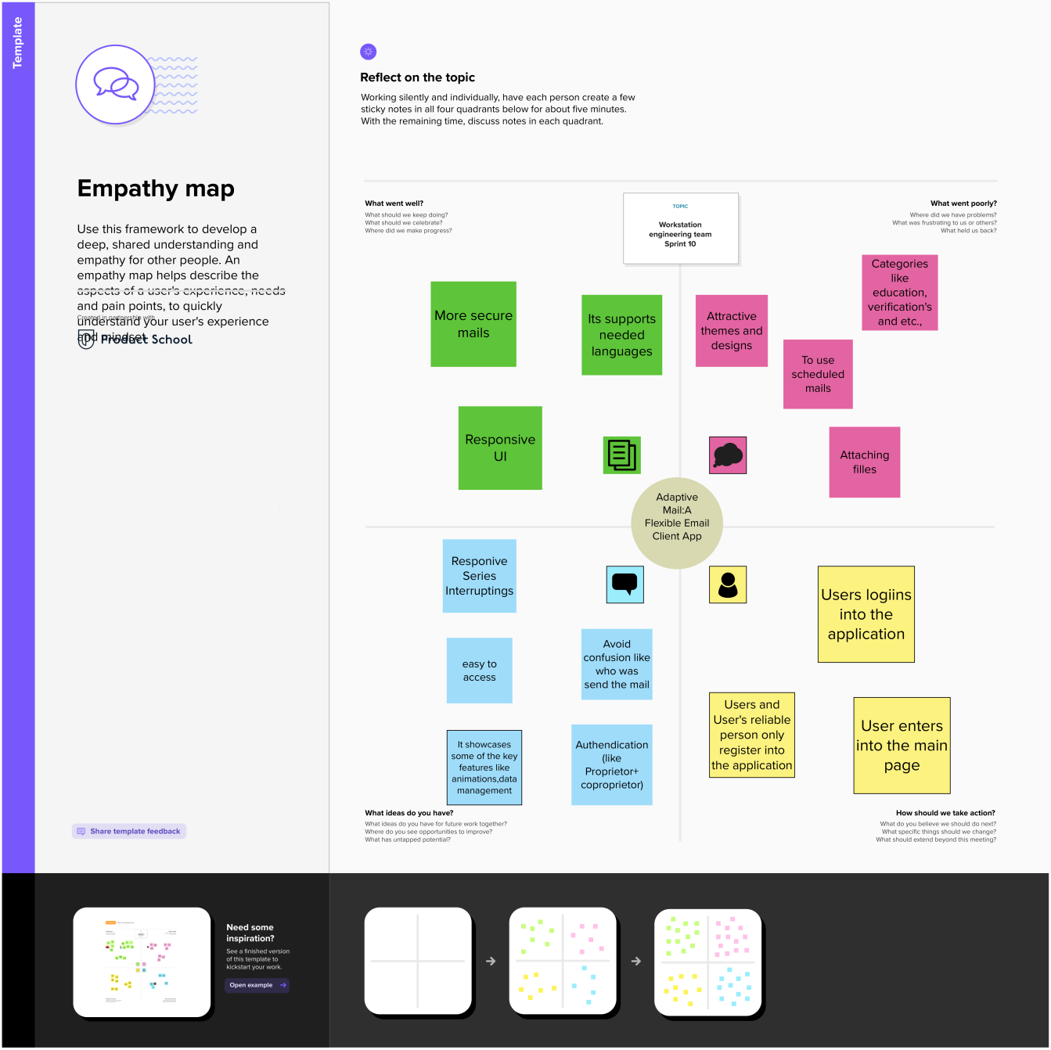

**2.2 Ideation & Brainstorming Map:**

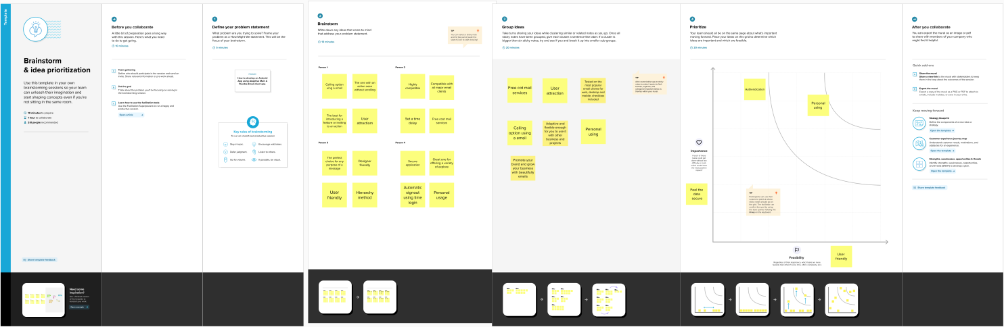

**RESULT**

**Sign in Page:**

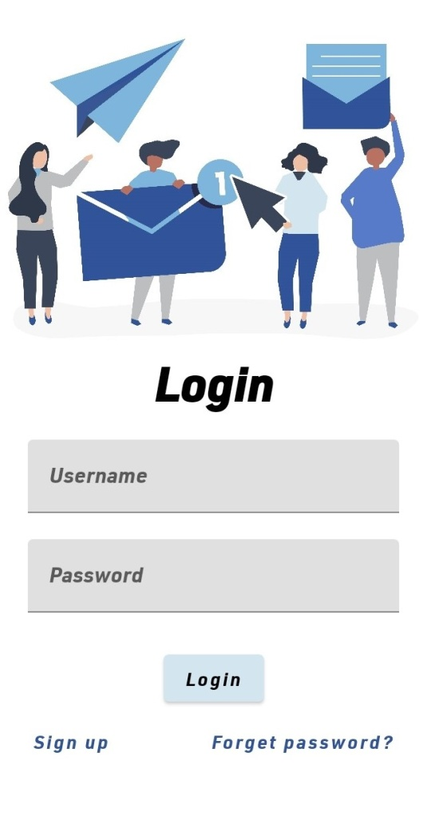

**Sign up page:**

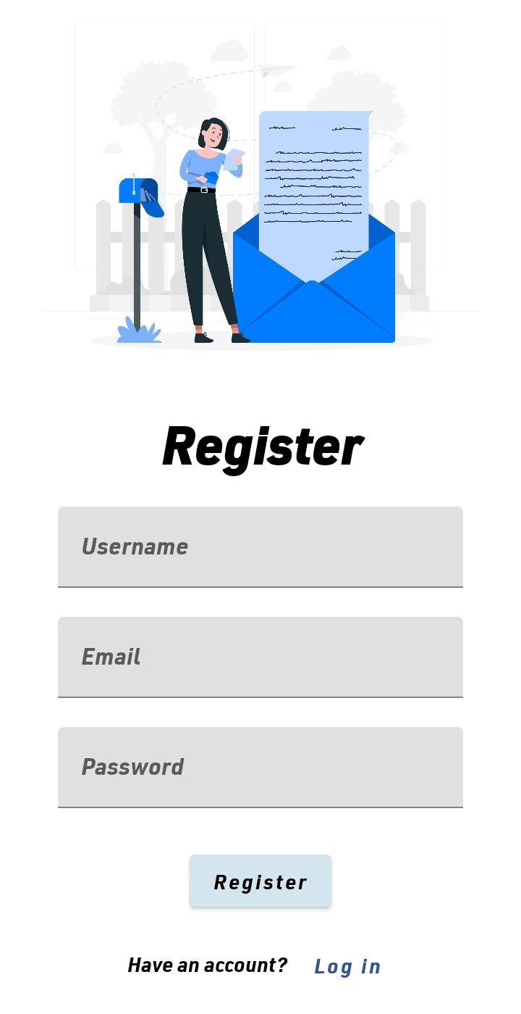

**Home Page:**

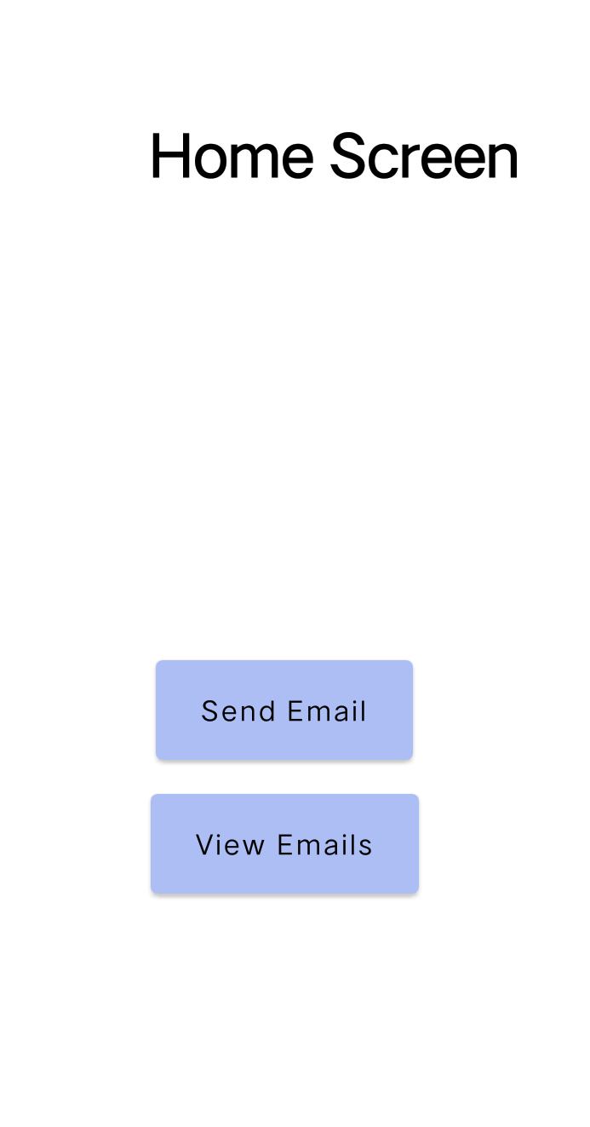

Email Page:

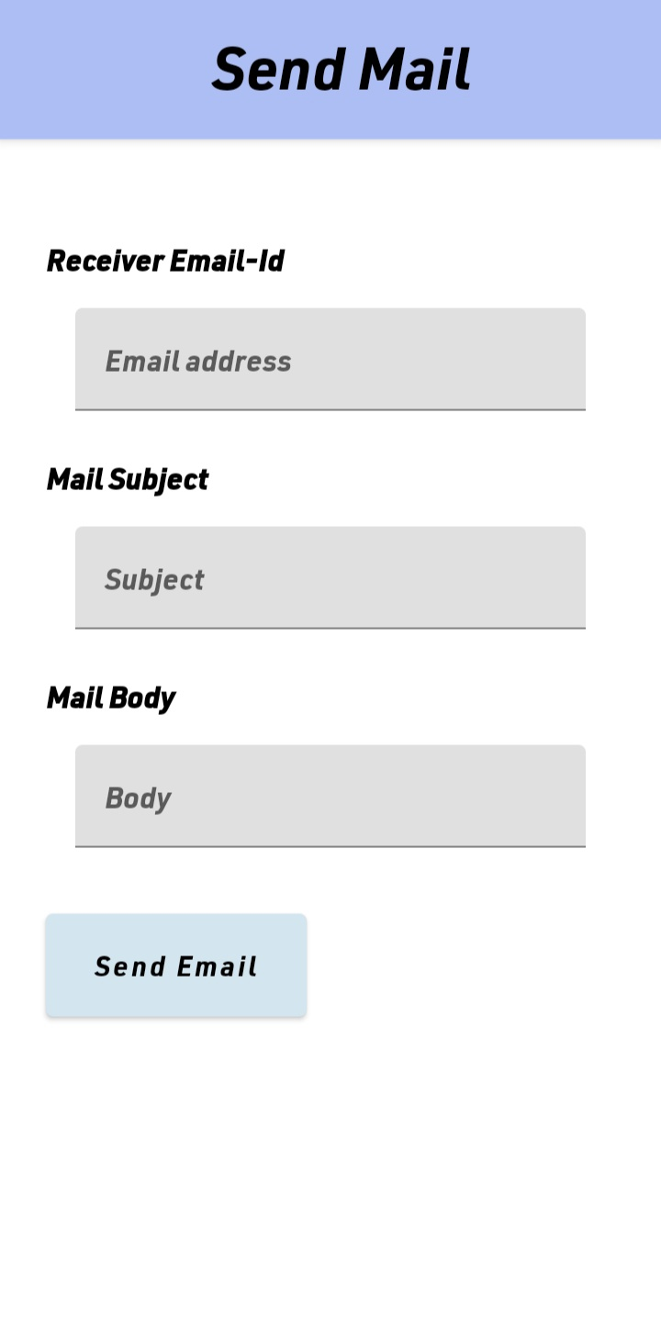

**ADVANTAGES & DISADVANTAGES**

* 1. **Advantages:**
* **Easy to reference**: Sent and received messages and attachments can be stored safely, logically and reliably.  It's a lot easier to organize emails than paper.
* **Easy to use**: Once you’re set up, sending and receiving messages is simple. That goes for a host of other email functions. Data storage and contacts can be accessed quickly and easily.
* **Speed**: Message to send? Done, under a second! Email is as fast a form of written communication as any.
* **Global**: Web based email means you can access your messages anywhere online.
  1. **Disadvantages:**
* **Emotional responses**: Some emails cause upset or anger.A reply in the heat of the moment can’t be easily retracted, but it can cause lasting damage.
* **Information overload**: Too many people send too much information. They cover their backs citing ‘need to know’ as the justification.
* **No Respite**: Your email inbox is like a garden; it needs to be constantly maintained. Leave it and will continue to grow.Ignore it at your peril!
* **Pressure to Reply**: Once it’s in your inbox, you feel an ever increasing obligation to act on it. Procrastinating doesn’t making it go away.  Do it, dump it or delegate it.
* **Spam**: Having to deal with spam and spoofs is one of the worst avoidable time wasters online.  Use anti-spam software.

**APPLICATIONS**

* Email is a very popular way of communicating with others over the Internet.
* It can be used in a educational setting to provide students with access to their course work or research.
* You can use email with an *email client*, an application that understands the various email transmission standards and allows you to send, receive, and read email.
* A adaptive mail app can be used in a business setting to provide employees with access to communicate to their industry or company.

**Conclusion**

We conclude that the Adaptive mail app would feature a sign-up and sign-in page, as well as a home page of adaptive mail. Great one for offering a variety of optional to explore. The perfect choice for any purpose of a message. User attraction, set a time delay, free cost mail service, user friendly, low cost mail services, security application, automatic signout using time lapse, and personal using. The adaptive mail app will not have offline access initially, but this will be added in a future update.

**Future Scopes**

* **Consumers will get more choices for email services.** New email service entrants will emerge as demand increases. In the next two years alone, the number of worldwide email accounts is [reportedly expected to continue growing](https://www.radicati.com/wp/wp-content/uploads/2020/01/Email_Statistics_Report,_2020-2024_Executive_Summary.pdf) at a slightly faster pace than the number of worldwide email users (3% per year — reaching 4.4 billion worldwide users by end of 2024).**Email intelligence will reach new levels.** Today, AI experts are already talking about the potential of [consciousness in technology](https://twitter.com/ilyasut/status/1491554478243258368?s=21). Before you know it, your email will become partially conscious. Similar to self-driving cars, email could someday become smart enough to self-compose, self-delete and even self-schedule meetings. While some of these predictions may sound far off, we may see some appear sooner than you think. If you are struggling with email pain points, don’t give up hope — your email experience is likely to keep improving as technology evolves.

**APPENDIX**

* 1. **Source Code:**